Module 6-Assignment-1
- After exploring all the datasets given in the approved dataset by use cases pdf, we chose a dataset from https://collegescorecard.ed.gov/data website.
- I downloaded openrefine from its website, followed the instructions to download and open it.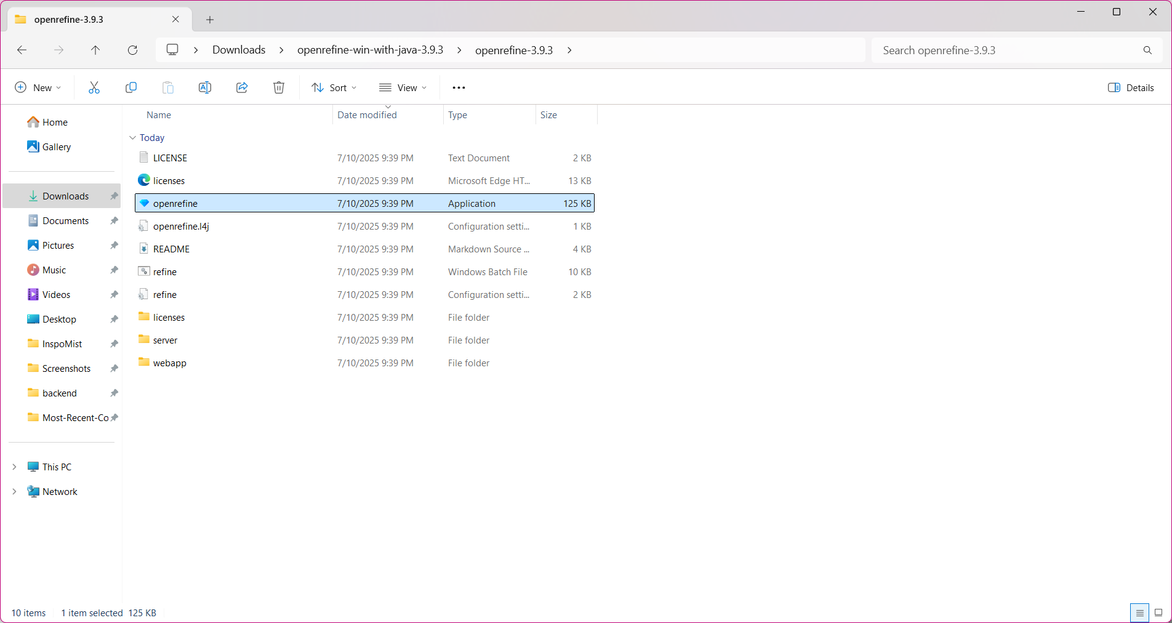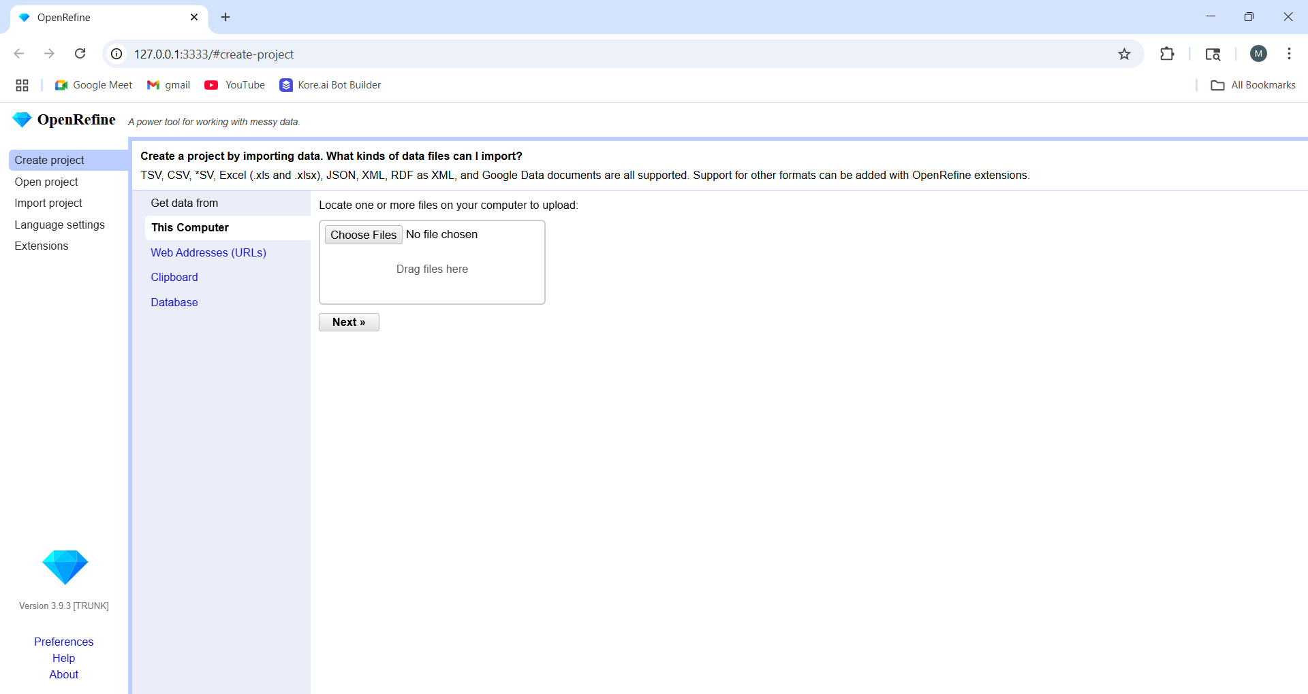
- I opened my dataset in openrefine by clicking on ‘chose file’(chose the dataset)’next’(reviewed the dataset)’create project’

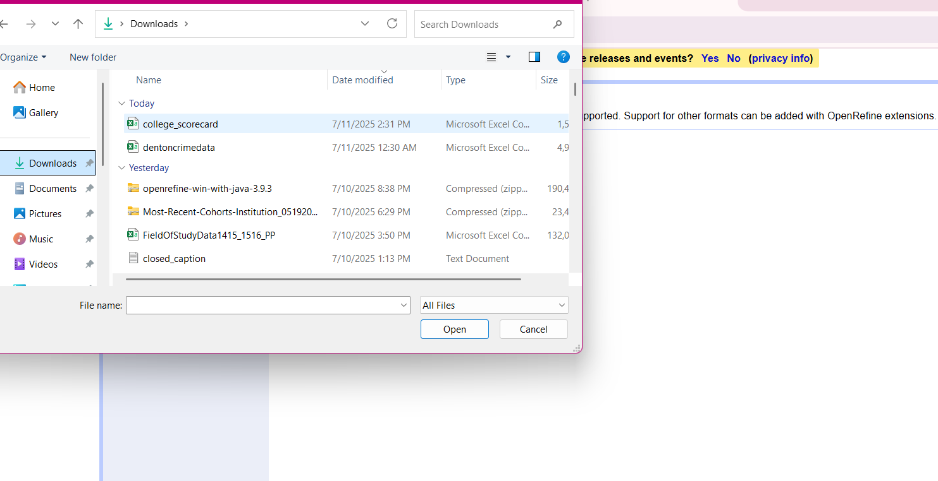
Made sure all the details on the bottom matched that showed mentioned in canvas and changed the project name to ‘final project’.
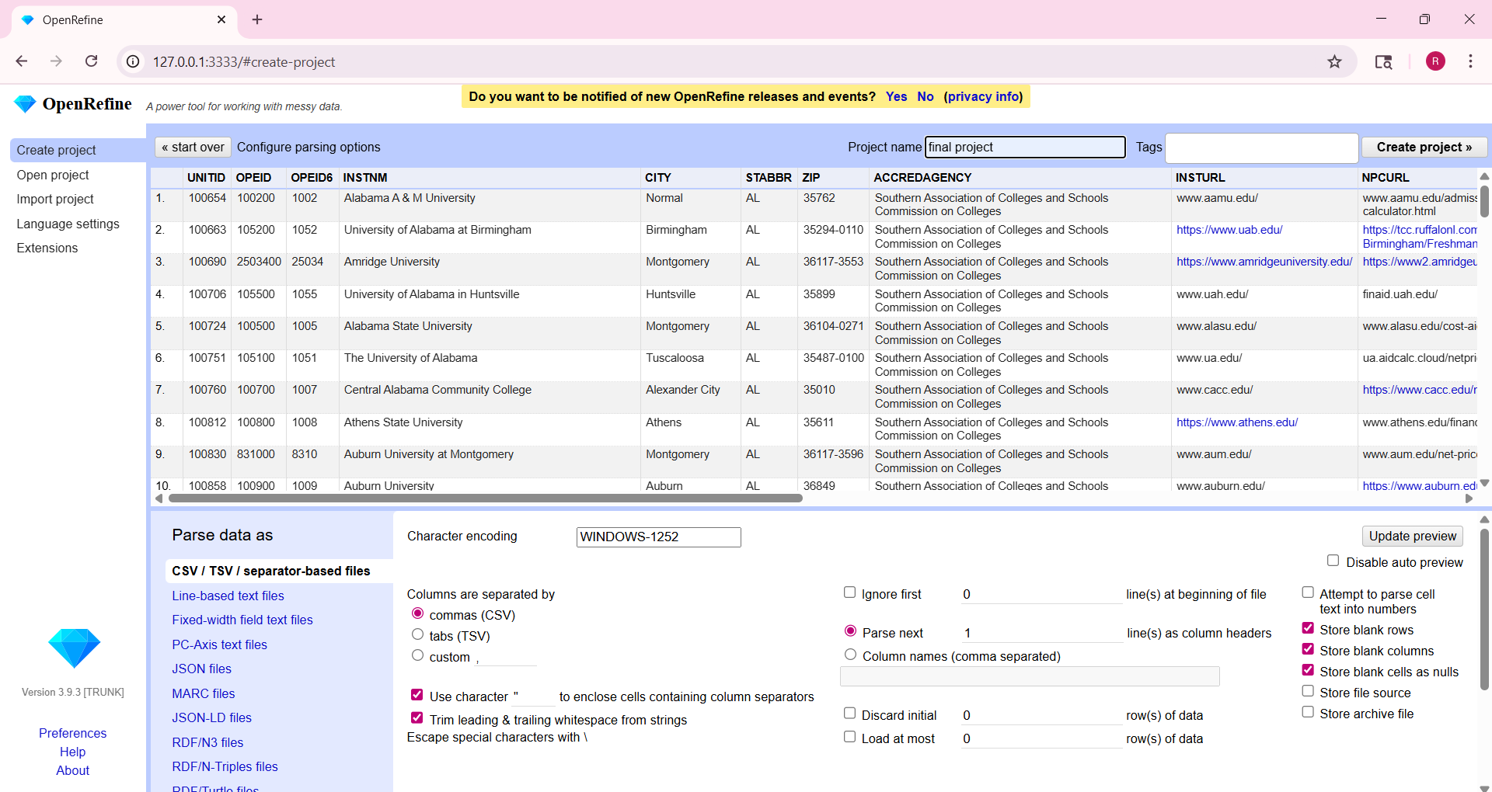
Created project: 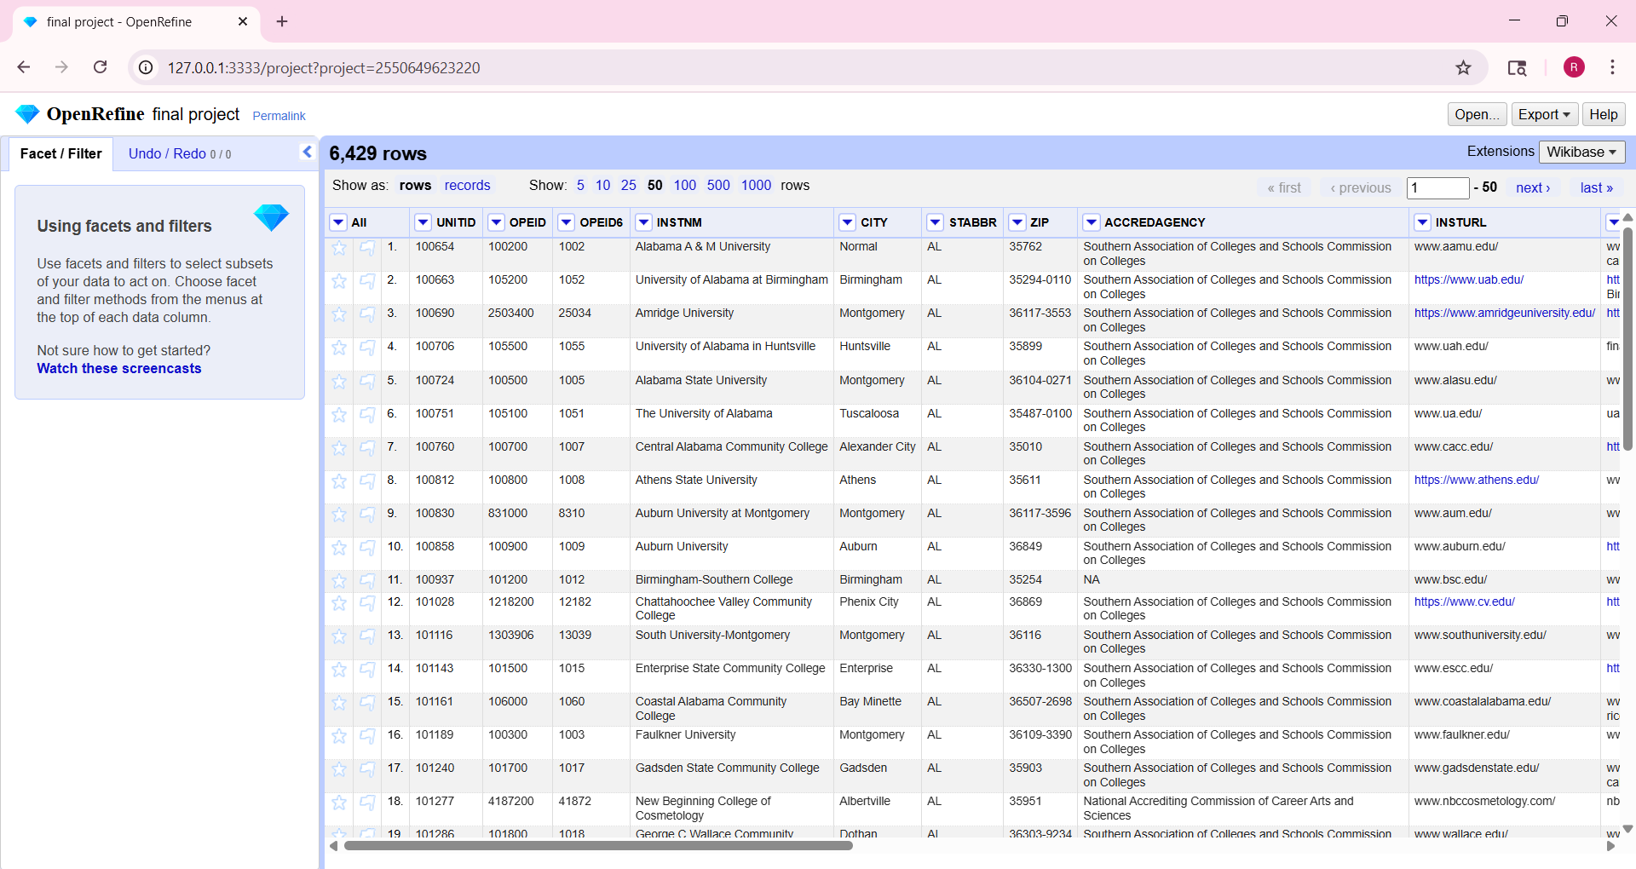
- We removed the unwanted columns by clicking on the drop down arrow beside the name of each column. There, selected ‘edit column’ ‘Remove this column’.
Repeated the same procedure on all columns until we were left with only the required columns, i.e, UNITID,INSTNM,CITY,STABBR,COSTT4_A,MD_EARN_WNE_P10,GRAD_DEBT_MDN_SUPP
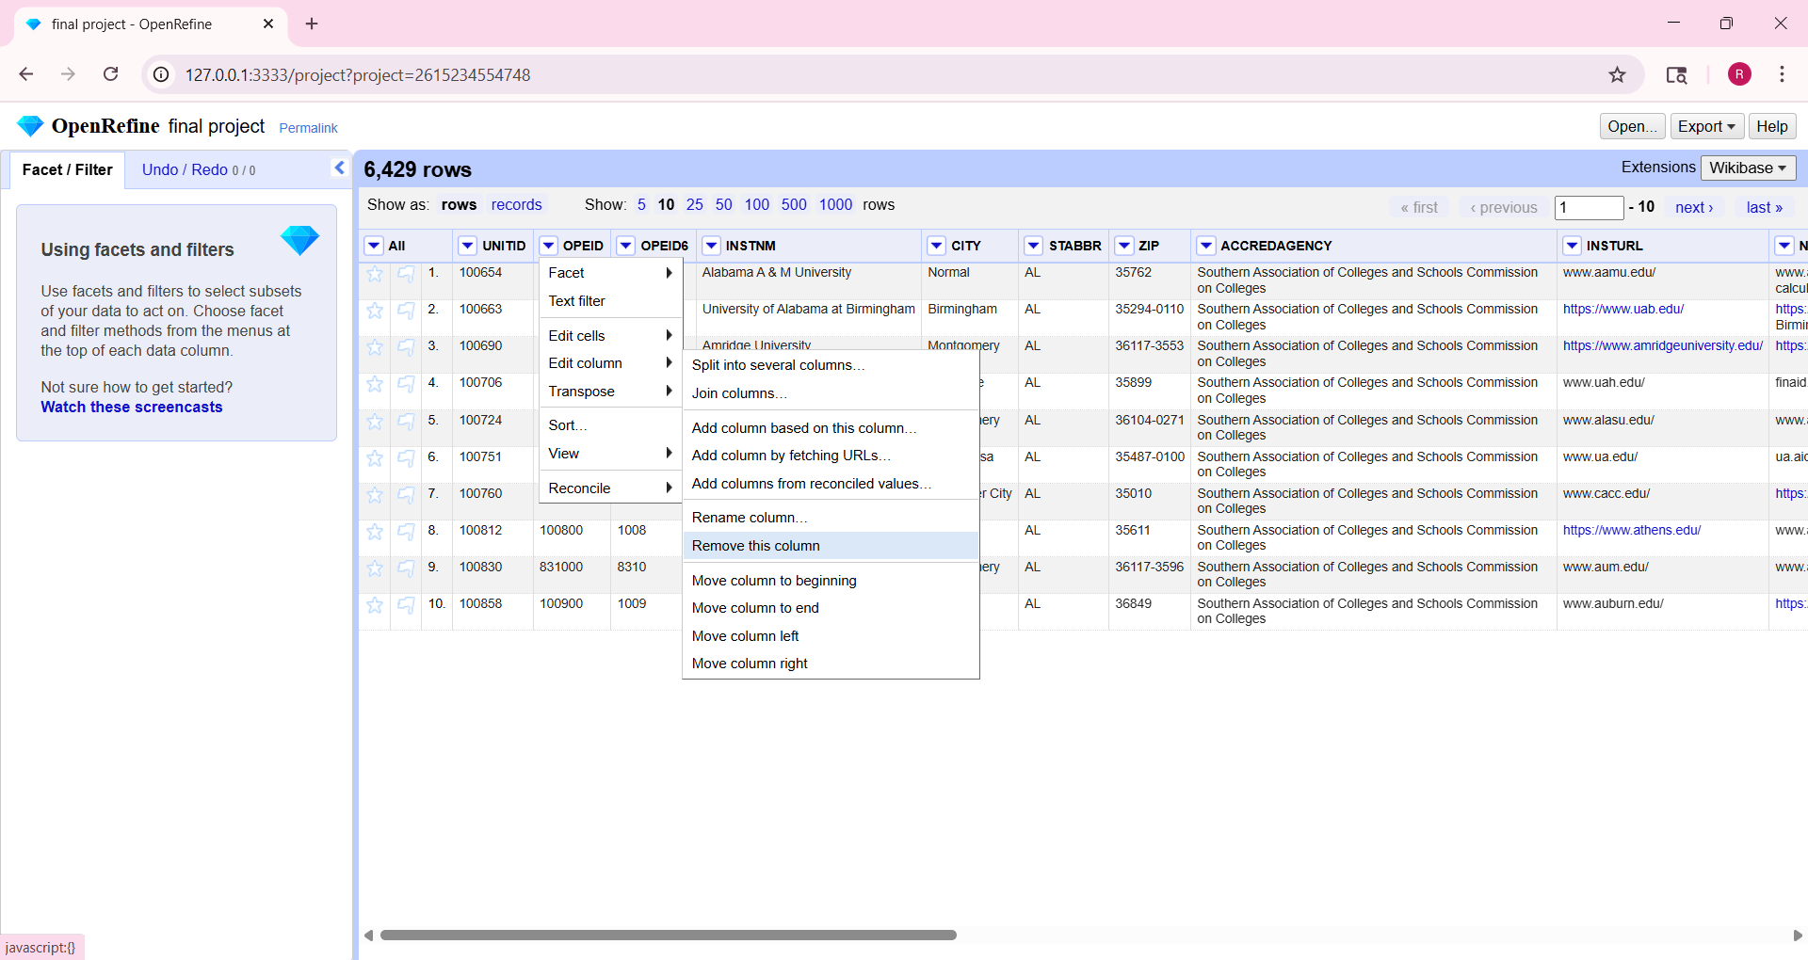
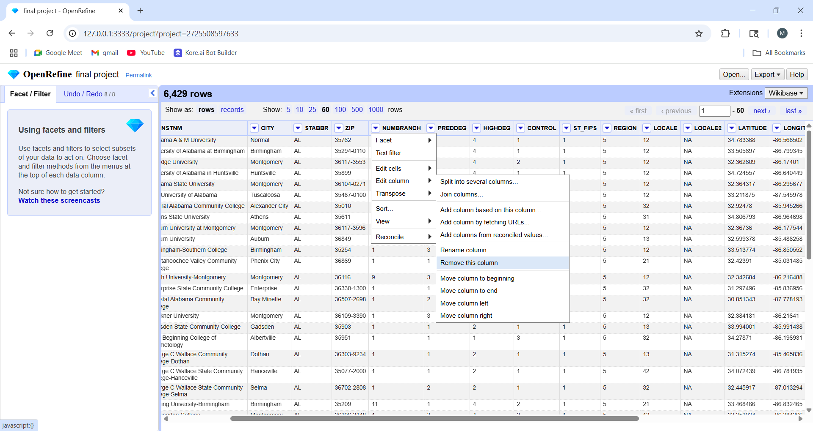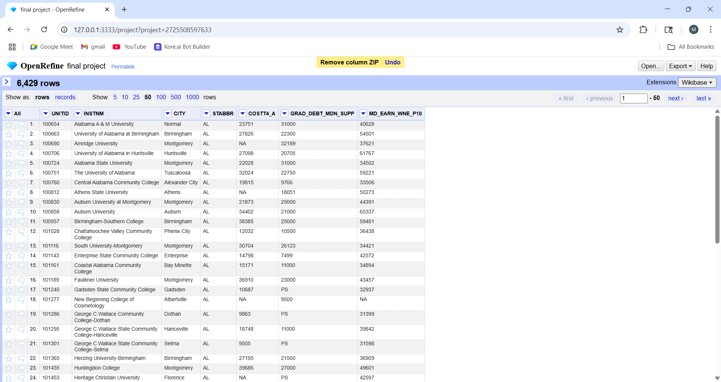
- Next, we converted the columns which had numbers to numeric from text to number.I did the same with the last three columns since they had numbers in them.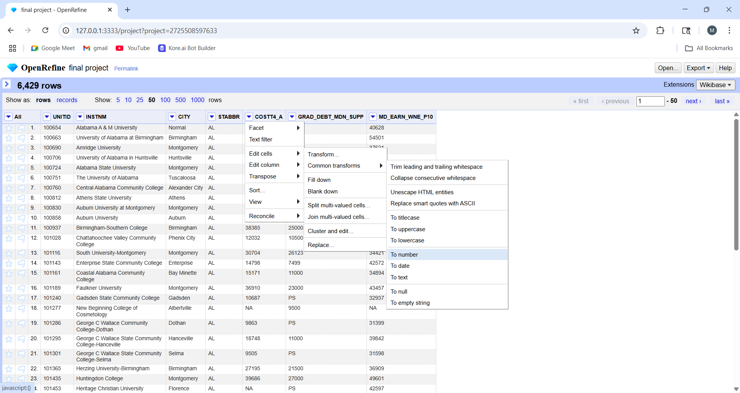
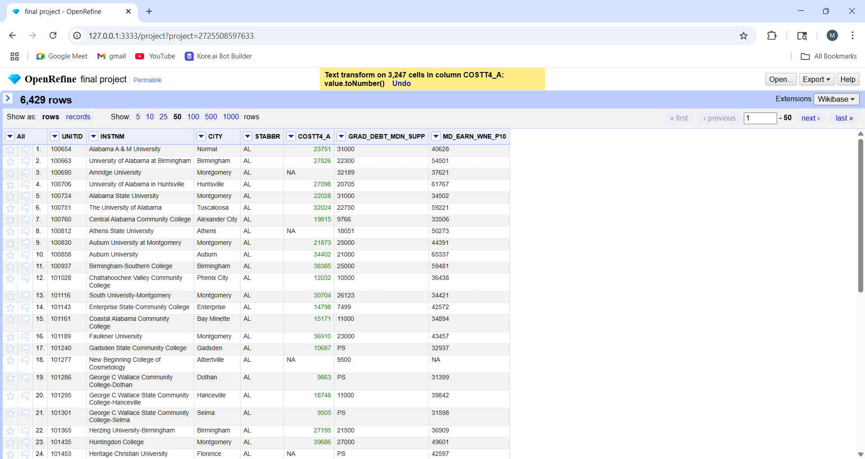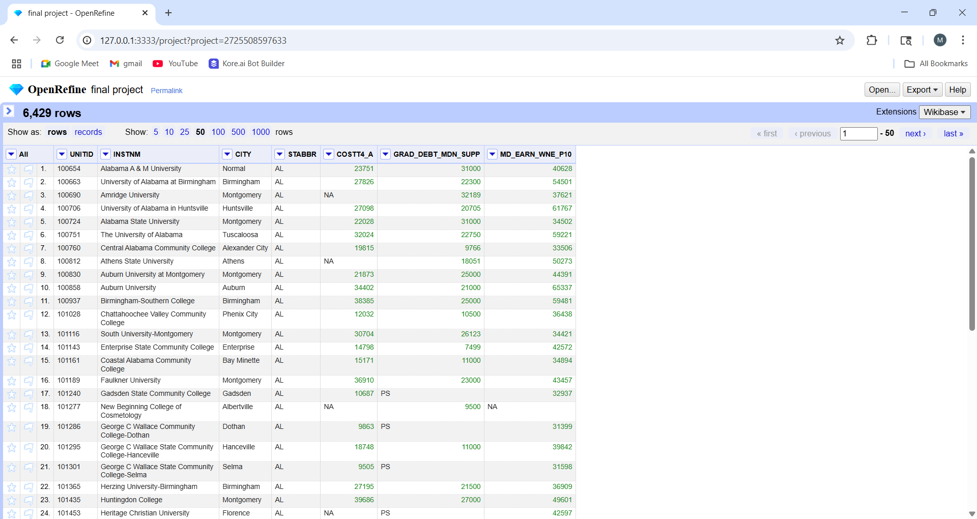
- Next , I renamed the columns for better understanding.
INSTNIMInst_Name
STABBState
costt4_A Tuition
GRAD_DEBT_MDN_SUPP Avg_Grad_Dept
MD_EARN_WNE_P10Avg_PostGrad_Earnings
For that, I clicked on the drop down arrow beside the column name and chose ‘’edit column’’’rename the column’ for each column.
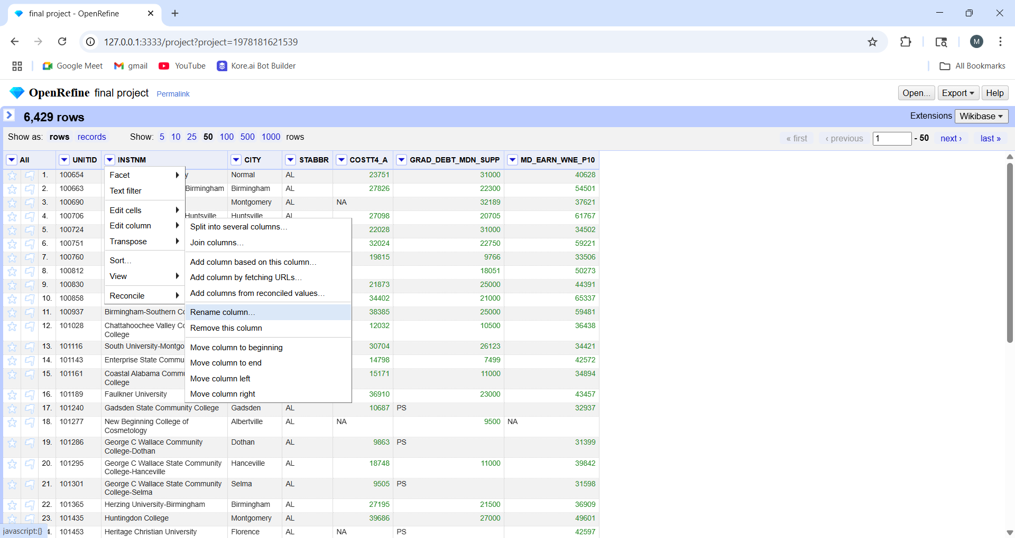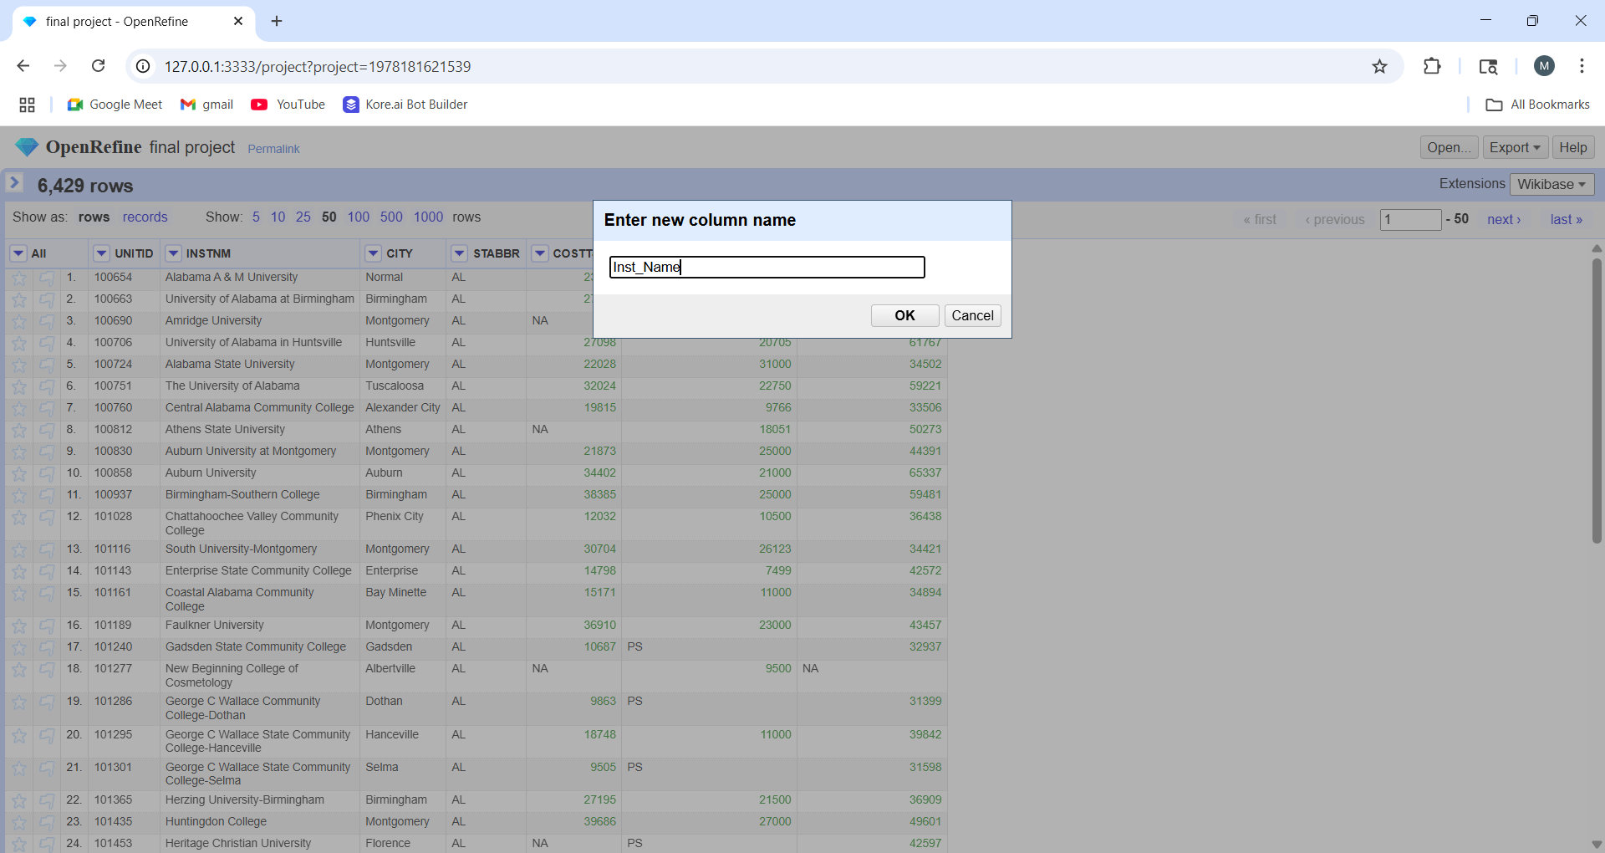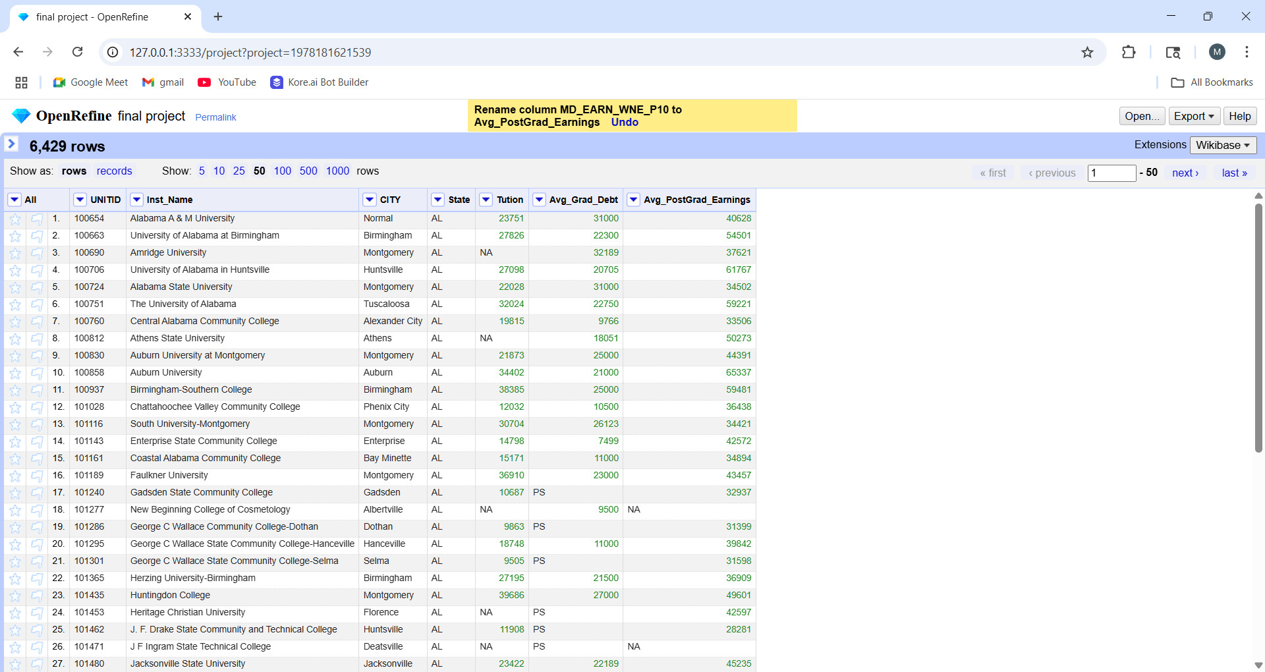
- Next, we removed the NA value, I opened the arrow on each of the last three columnsfacet numeric facetonly check the non-numeric on the left side graph(selects ‘NA’ or PS automatically) dropdown of “All”edit rowsdelete all matching rows .
Repeated the same process for the last three columns. 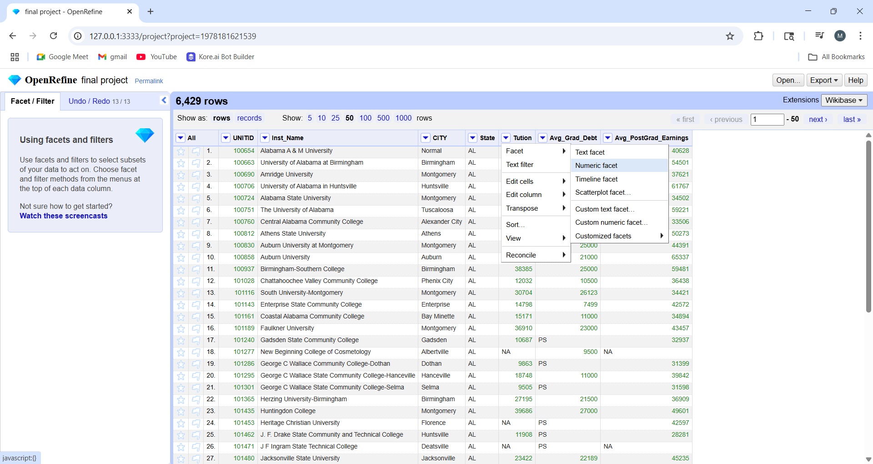 All the ‘NA’ got selected automatically.
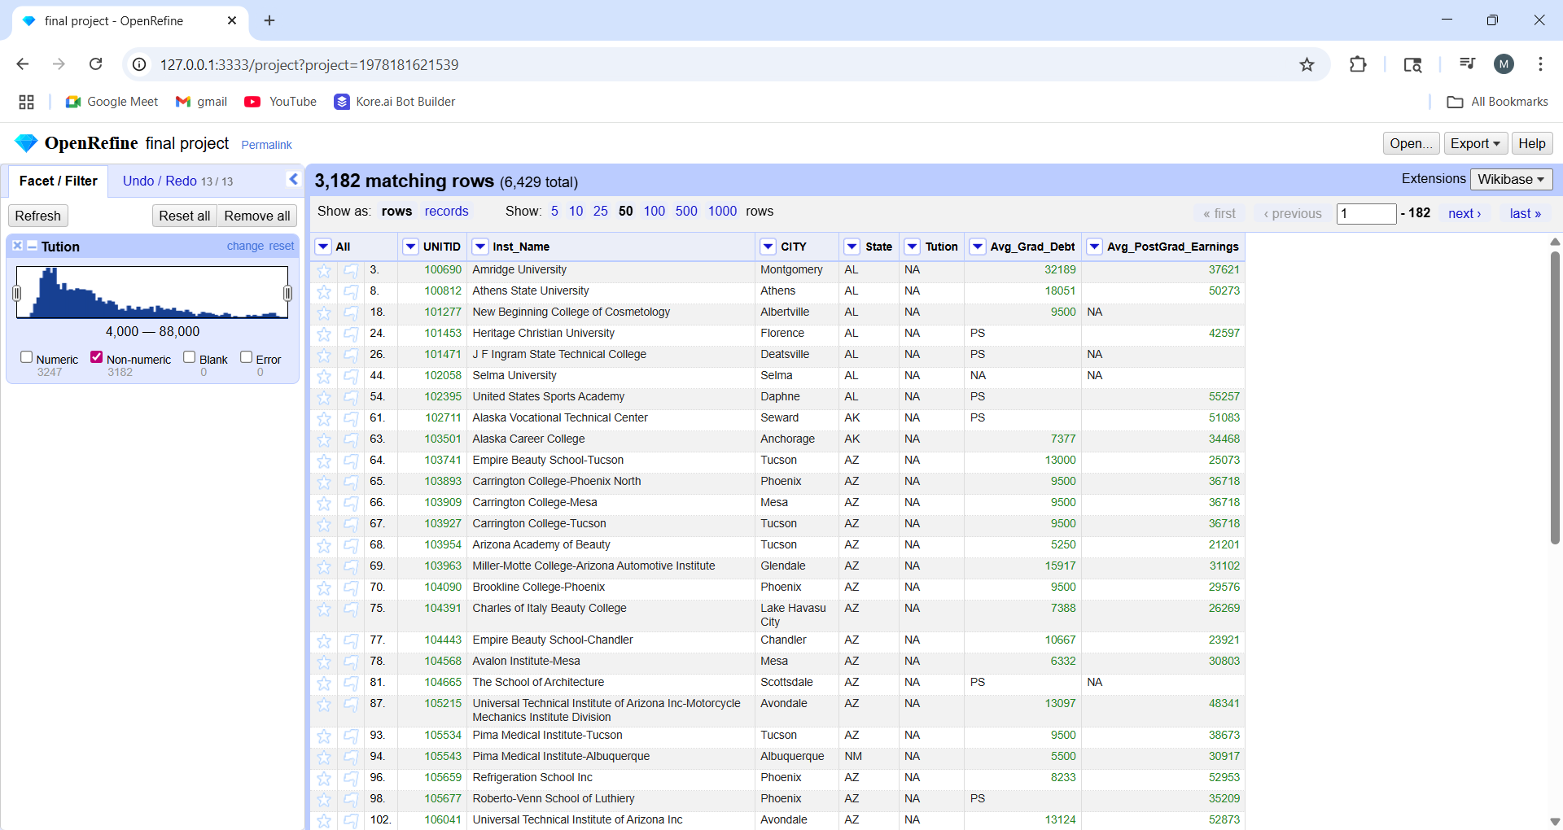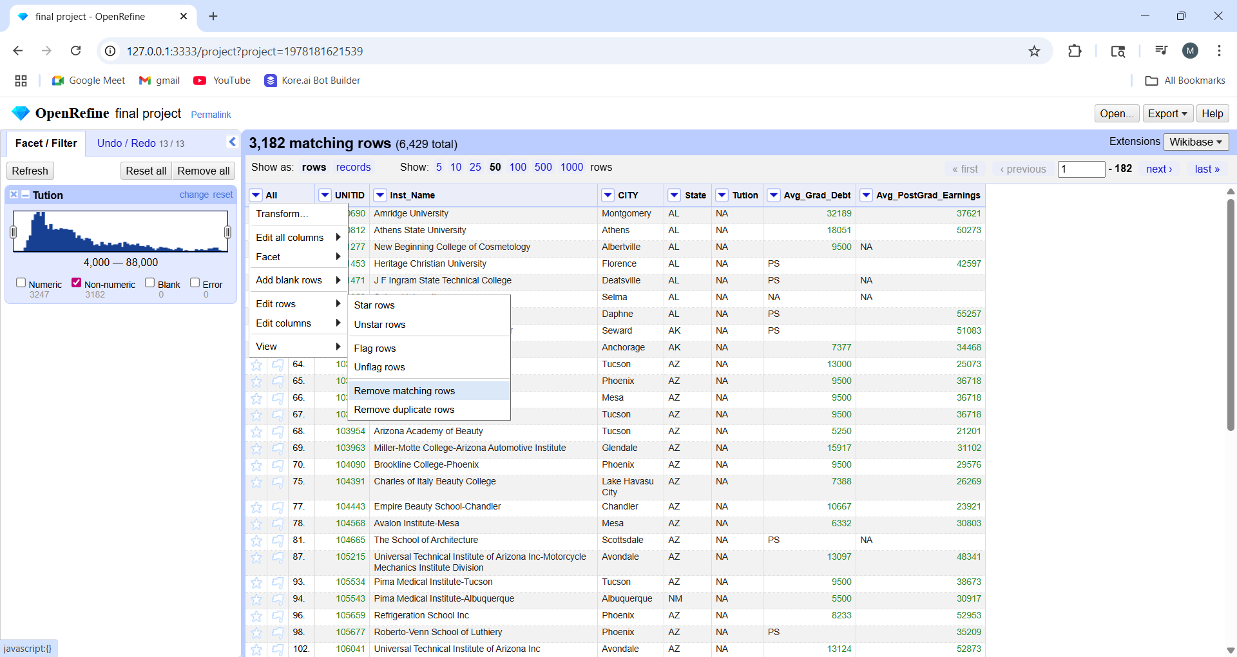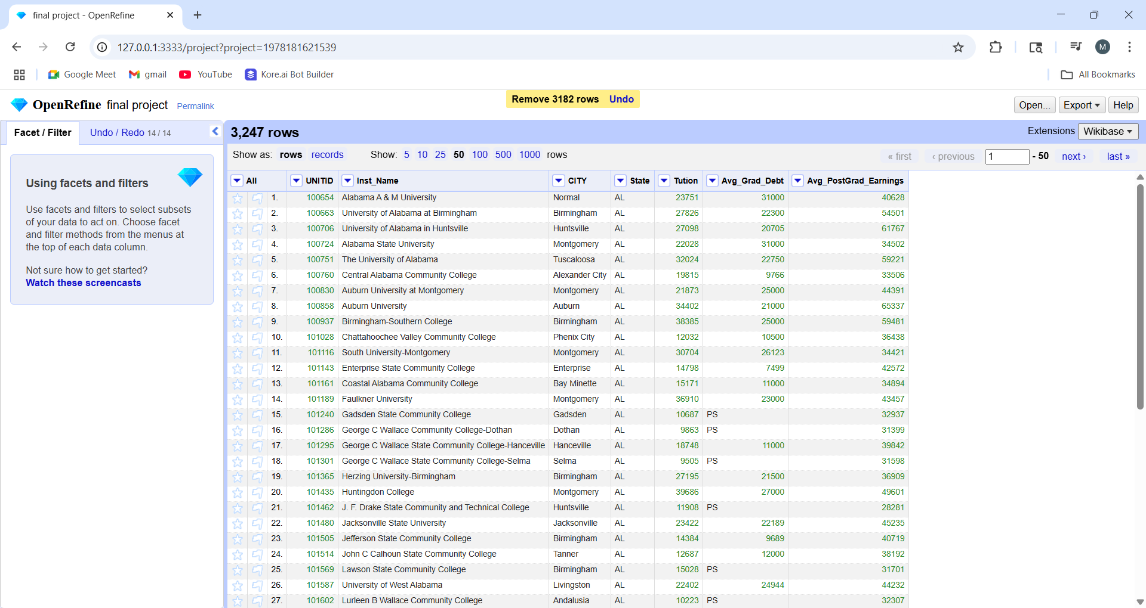

After deleting all those rows, we finally have the cleaned dataset as below. 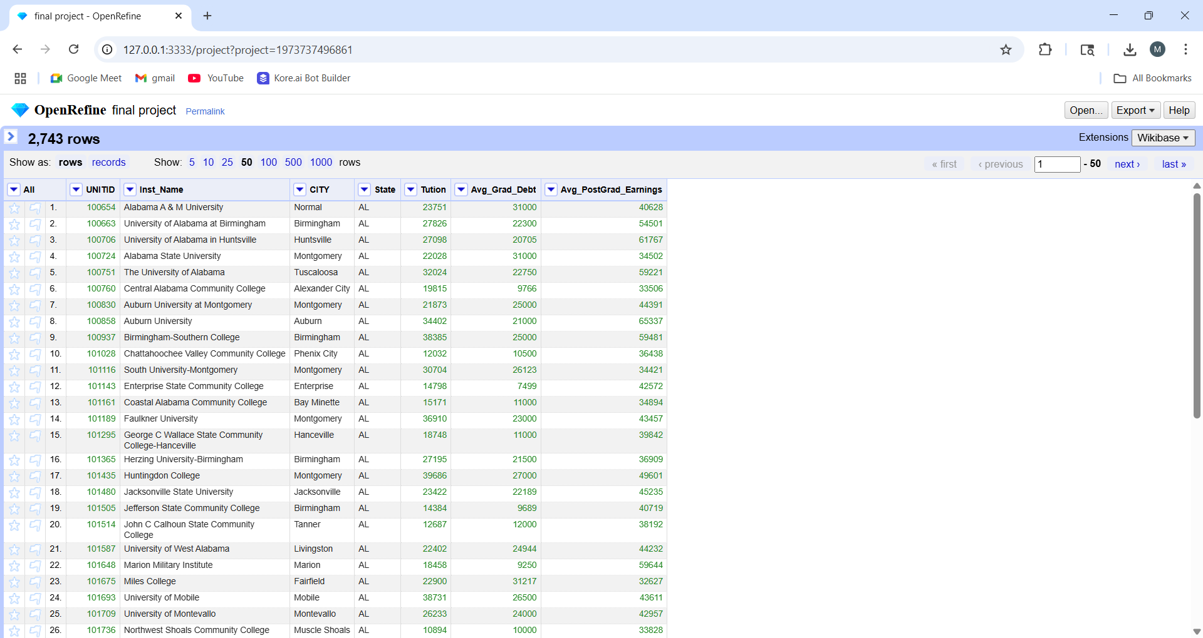
- We finally downloaded this cleaned datset by clicking on ‘export’’column seperated file’ 